Collecting Technology Data Through Google Analytics

Website/SEO Assignments

NAME: Tahiya Rahman

horizontal line

# About the Data

The purpose of the paper is to find out the Technology trends for NSTEM users where the most used browser/ the browser creating more visitors from the user flow had been observed. The technology trend analysis is dimensional. Each week there can be a shift due to different reasons within the device users. The shift sometimes shows a steady pace or unstable state. All depends on the user and adopted trends in technology.

# Comparison of Data over Different Time Periods

March 12th, 2023 - March 19th, 2023

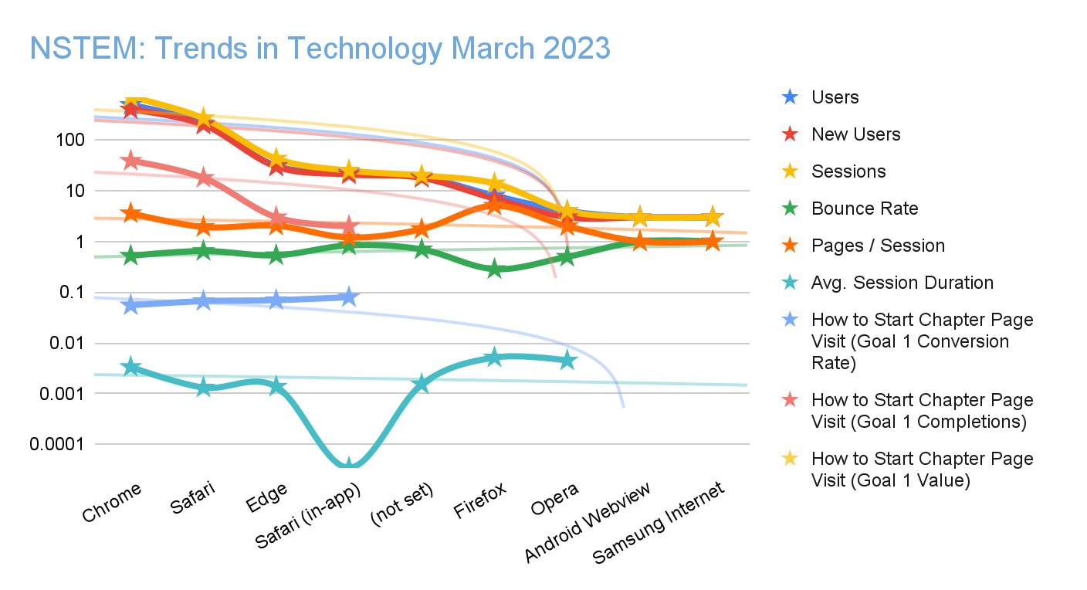

* As the data shown above, a clear analysis, the calculation for the technology trend is to find out by the user behavior session and the session/page. The log scale shows all the data within the original source. Trendlines have been calculated to the logarithmic scale to support the highest users.
* Generally Chrome has the highest compatibility for visiting the websites and gained the highest popularity for browsing. From this perspective, Chrome users are more likely to create a decent session for page visits.
* There is a negative slope for Safari(in-app) which can be caused due to lack of advertising.
* From all the metrics, Firefox stood out among other outstanding performers. The new users and pages/session has been observed as a significant increase and a potential metric to invest for future.

# Users by days

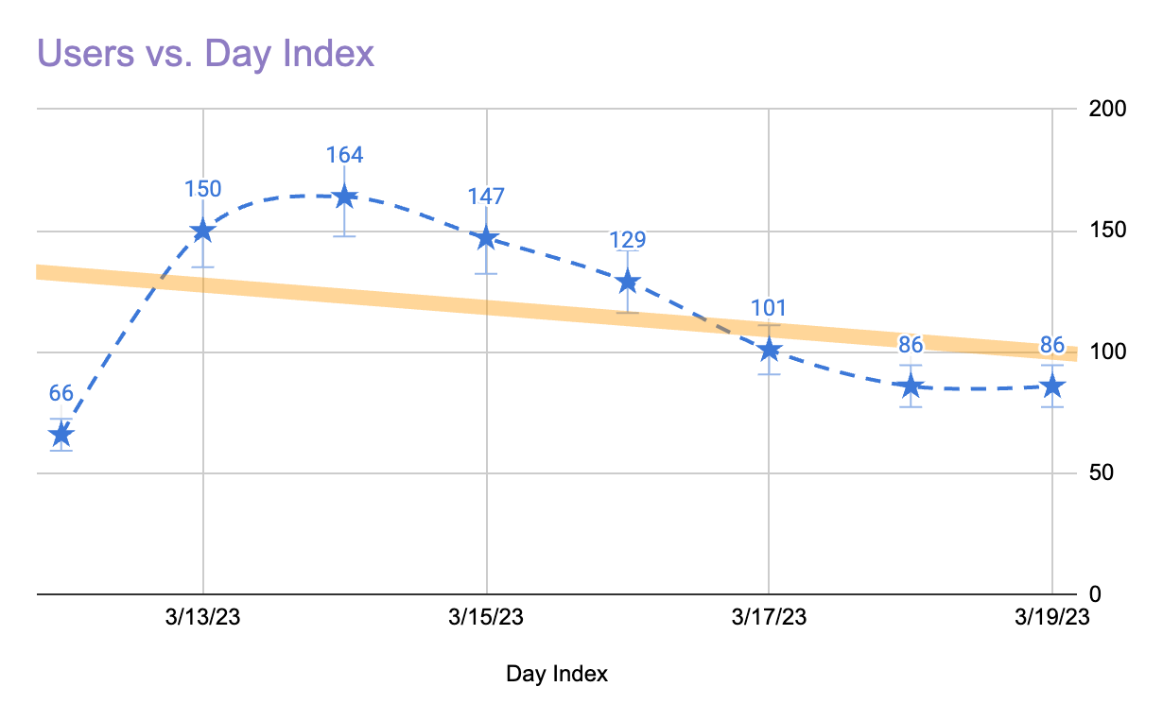

* From the Day index of March 2023, most traffic was generated on 14th March. Gradually it decreased from 14th March and hope to pick up a decent rate for the next week again.

# What NSTEM Should Continue Doing

* NSTEM should continue their paid search for Google Chrome as it shows a good potential probability to bring more leads.
* NSTEM should create more ads for firefox and biddings. Because firefox also showed a good performance with its heavy users, new users and users visiting page/session.

# Ways to Improve the Website

* NSTEM can introduce mobile apps for parents and students. So they can track their billing, chapter development and access/purchase merchandise stores easily from the mobile app. Because mobile is the most user friendly and convenient way to access any information. So it would be a wise decision if NSTEM can create mobile apps for the students and parents for easy accessibility.

# Data that Stands Out

From the analysis, the data stood out as the Firefox with its decent rate of new users and users who are visiting NSTEM website. Mostly the parents are the users for the firefox as it is used as an universal web access tool and pretty outdated. But the fact is, data showed us , it still counts as a potential scope for future investments.

# Conclusion

To conclude, there is no alternative to the technology and its power to attract the users more for the development of the business in NSTEM and increase more students for its chapters development.

Google Sheets: <https://docs.google.com/spreadsheets/d/1WLnifrtdXHAgsGoSg_wAZ7ub1e3esopL8DVCvKocJ5U/edit?usp=sharing>